

Saalu Dahal

[Email address]

Saalu Dahal

COLLEGE ID 180063

[salu.dahal@gmail.com](mailto:salu.dahal@gmail.com)

Ticket Booking

Concerts/Live Music College id- 180063

Table of Contents

1. Introduction 2

a. Project Introduction 2

b. Justification of the project 2

i. Background of the project 2

ii. Problem statement 3

c. Description of the Project 3

i. Features of ticket booking 3

2. Aims and Objectives of the Project 4

iii. Development Methodology 4

a. Methodology to be used 4

b. Design Pattern 6

iv. Configuration Management 7

Conclusion 12

4. References 12

# Introduction

## Project Introduction

Ticket booking of the concerts & live show:

It is an event representing technology platform powering various concerts, live music on estimated date, time and occasion. Concerts, live music has always been popular among youngsters and we can find millions of people lining up to get ticket or camping overnight just to get the seat. So online ticketing has taken the platform as it has become the easiest way to book ticket. People can campout on their personal gadgets and make the purchase from their own home. This web application helps the people to save the time and get any tickets easily of the concert that they prefer to. The main goal of this application is to provide the best services possible to people, designing simple UI and making this entertainment sector more better as In this application not only the concerts tickets are available but also any restaurant can organize their live session and get promoted through this app and this will help any other business to get involved and sell off their ticket.

## Justification of the project

In every aspect there is both positive and negative interface. Though this field covers more flaws but once this project is applied in the market and people get used to apply it, it can cover up all the flaws and make people’s life go in manageable path. This will be the flexible project where people won’t have to face problem while using its interface as it will be designed user friendly.

### Background of the project

We can find various ticket booking application successfully running in the market but also people are facing problem and lining up to get the ticket. This application aims to get over all the generations. It is vital to get connected with customers as connection plays a role over the development of website. We can get to know how promoted the website gets among the mass. And this also helps to produce the valued content. The website is also designed simple and with responsive so it can get access in all types of gadgets. The responsiveness website also later helps to produce more leads.

## Problem statement

As per the record of ticket for concerts/live music people are facing a lot of difficulty. Wasting time on lining up or missing the favorite performance leads towards the disappointment. Also, we can find the ticket selling on black market as it costs the double amount than the required. Though there are application used for ticket booking but according to the information gathering most of them doesn’t keep the record properly or are trustworthy. Available tickets are too costly for the people as most of the business gets involved in unnecessary promotion and increase the ticket rate. Customers has the power to change the business to brand so making their life entertainment and easier should always be the first priority for every business.

# Description of the Project

## Features of ticket booking

* Registration
* Login
* Data collection
* Ticket reservation services
* Responsive and Simple UI
* Registration: New account accessible for users and data can be collected with the number of new entries.
* Login: Verifies required users and to implement reasonable security. Data rest
* Data collection: for customers security and to manage the required seat as required in concerts.
* Ticket reservation services: for customer service and can easily get the ticket and save time and energy. And make the platform where user doesn’t have to wait long to get ticket at a simple access ticket or payment can be done.
* Responsive and Simple UI: Simple and responsive interface helps the user to access the website easily and can also use the sites to various gadgets easily.
* Pages of band/brand: attraction of the customers and promotion of various restaurant and brand which is beneficial both in marketing and earning and customers can also gain the details about the event going on.

# Aims and Objectives of the Project

Aims

1. To provide the ticket with better facilities and with the low cost comparing to others
2. To provide the facility to other businesslike restaurant to get promoted through application.
3. To make simple UI and responsive design so that every people can easily access the application.
4. To secure the data of the people.

Objectives

1. As of many application tickets booking of concerts/live music provides the ticket at low price and people can attend easily all the available concerts whenever they prefer with better facilities.
2. Restaurant can organize their live session and get promoted through this app as this will help any other business to get involved and sell off their ticket.
3. Data collection is available with full confidential security.

# Development Methodology

## Methodology to be used

For the project I will prefer to use the waterfall methodology as it is simple and quick to operate. Also, the project is small where waterfall model is mostly appropriate.

Waterfall model is the sequential approach to the software development life cycle. It is appropriate for the fixed known requirements, establishment of time management and known technology. It helps in arranging the task in more disciplined way.

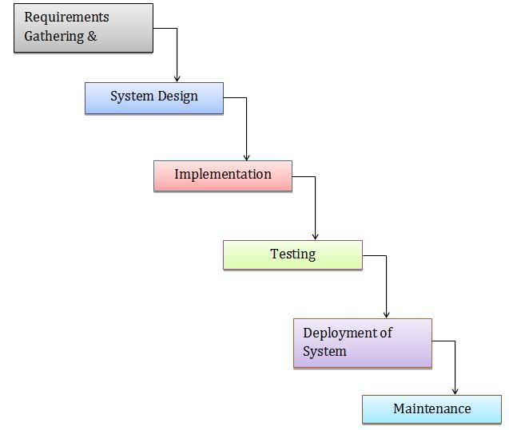

Figure 1 Waterfall Model

## Design Pattern

MVC is an architectural pattern which is used in designing, structure of the application and helps in creating interfaces. This design pattern is simple and easy to operate and understand. So, I will prefer this design pattern in the application to manage the code and design in standard way. MVC stands for module, view, controller where it separated out into three different way and makes the developer easy to access the code as well it reduces time and complexity. These days many developers implement MVC pattern as it is used in various programming language.

The MVC establish the components that is used in the development. They are

• Module: Module contains the core logic of the program. In the application module represents the logical structure of data and has class of high-level connection.

• View: It represents the information of the system as here information with multiple views is possible. It displays the objects within application and also includes everything that can view by the user.

• Controller: It helps in the communication between model and view as it indicates the classes that can connect the model and view. Controller contains the event handlers which triggers specific methods in the program. Controller helps view communicate with module of the application.

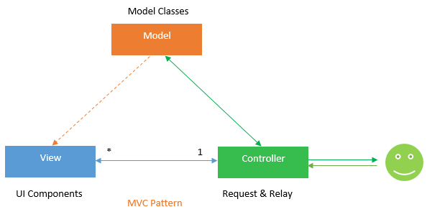

Figure 2 Model View Controller

# Configuration Management

The configuration management is used to identify and track individual configuration items, documenting functional capabilities and independencies. The developers use configuration management tools to verify the effect a change to one configuration item has on other systems.

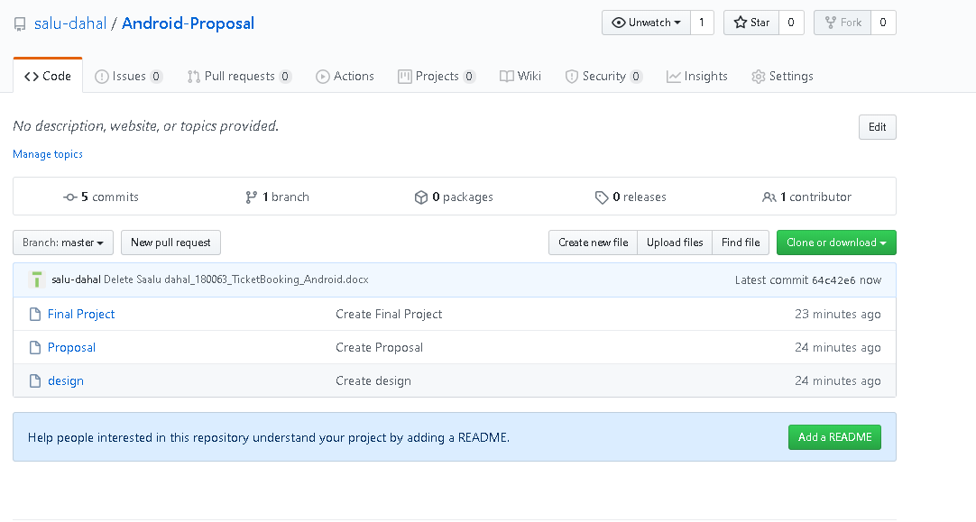

1. Prototyping

Before the full development of the project this phase is done to clear out the bugs and reduce the user dissatisfaction as user can get involved in this phase and give their views toward the initial phase of the development. This design is done at Balsamiq-Mockups.

Login form

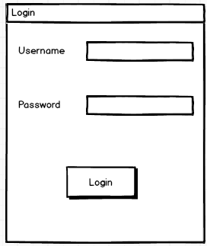

Registration form

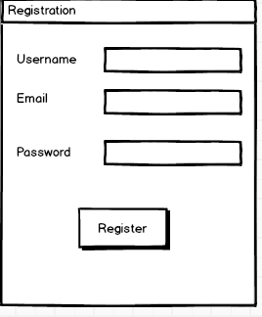

Add show

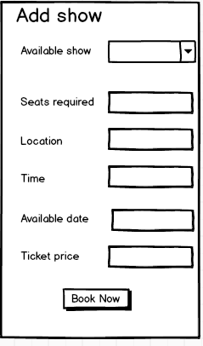

Edit show

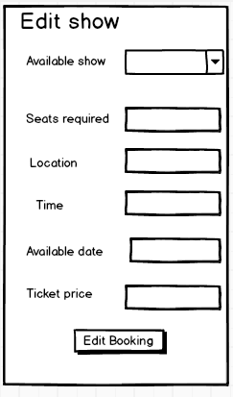

Dashboard

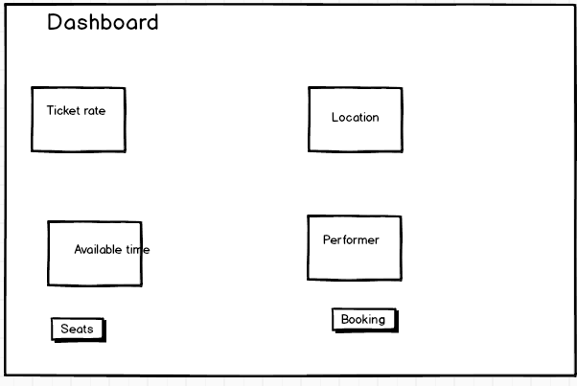

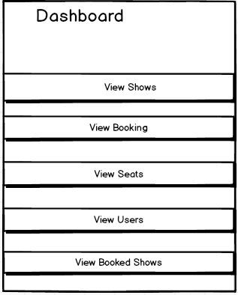

Ticket Boking

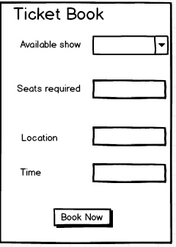

# Conclusion

The project Ticket booking of Live shows and Concerts is designed adding all the required features, aims and with its objectives. For the clear project prototyping is done so that required requirement can be easily recognized. To avoid the mistake the problem statement and background of the project has also been gathered properly.

# 4. References

1. Try Booking. 2020. *Sell Tickets Online with Our Affordable Ticketing Platform*. [online] Available at: <https://www.trybooking.com/sell-tickets> [Accessed 13 May 2020].
2. viagogo.com. 2020. [online] Available at: <https://www.viagogo.com/Concert-Tickets> [Accessed 13 May 2020].
3. Ticketmaster. 2020. *Ticketmaster: Buy Verified Tickets For Concerts, Sports, Theater And Events*. [online] Available at: <https://www.ticketmaster.com/> [Accessed 14 May 2020].